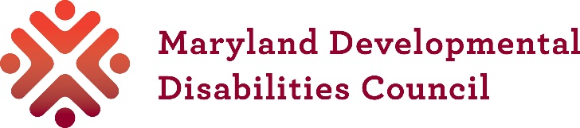

Small Grant: PROJECT
Application

Only use this application for Small Grant Projects. There is a different application if you are requesting a grant for a training in Maryland.

Date:
Name of person or organization:
Contact person and title, if an organization:
Address:
Email:
Phone:

- What do you plan to do if awarded a small grant? Describe your project.

- How does your project make progress on the Council’s mission, vision, and State Plan?

- Why is your project needed?

- What are you going to do? Describe the specific activities grant funds will be used for?

- Who will benefit from the project? How many people?

- What will change or improve because of your project?

- How will you know you were successful? For example, will you collect information, complete surveys, and/or carry out other activities to evaluate this?

- Who will work on your project?

- What is the timeline for your project?

- Will your project activities continue in any way after the Council grant ends? If so, what do you plan to do and how will you fund it?

- Is there other important information that helps explain why your project should be funded? (optional)

Email this Application and the Small Grant Budget form to: info@md-council.org. The Council will send you an email when we get your application. If you have not received an email within 5 working days, contact the Council at 410-767-3670.

