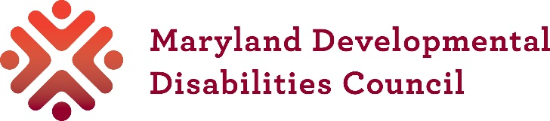
Small Grant: TRAINING IN MARYLAND
Application

Only use this application if you want a grant to help with costs of a training in Maryland. There is a different application for other types of small grants.

Date:
Name of organization:
Contact person and title:
Address:
Email:
Phone:

1. Name of your conference or training:

2. Date(s) and location of your conference or training:

3. Is anyone hosting the conference or training with you?

4. How does this training make progress on the Council’s mission, vision, and State Plan?

5. Description of your conference or training:

- Purpose:

- Topics and information that will be covered

- Speakers/trainers

Send conference or training materials that describe topics and speakers with your application if you have them.

6. Attendance:

- Who will attend?

- How many people do you expect?

- Will most of the people coming be people with developmental disabilities, their family members, advocates, or professionals?

7. Outcomes:
- What knowledge and skills will people gain?

- How will they use the knowledge and skills after the conference or training?

8. Will there be a registration fee? If so, how much?

Email this Application and the Small Grant Budget form to: info@md-council.org. The Council will send you an email when we get your application. If you have not received an email within 5 working days, contact the Council at 410-767-3670.

